Glasgow Lands Registration

c/o Maggie Carchrie, BATD

53 Loon Place

South Windsor, CT 06074



2017 Highland Dance Competition

USE-0108

Northampton, MA

July 15, 2017

Look Park

300 North Main St.

Florence (Northampton), Massachusetts 01062

**About Look Park:** More than 150 acres of wooded picnic areas including water spray park and pedal boats *(www.lookpark.org)*

**Accommodations and Camping**

Many options can be found in the greater Northampton, Westfield, and Springfield areas.

**More info:*www.glasgowlands.org***

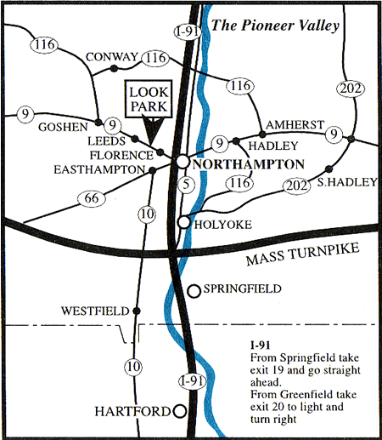

**From the South**

I-91 N to Exit 19, go straight ahead for 3.4 miles. Look Park is directly ahead.

**From the North**

I-91 S to Exit 20. Turn right at light onto Bridge Road. Follow for 2.4 miles; Look Park is directly ahead.

**From the East or West**

Mass Pike, I-90 to Exit 4, I-91 N. Follow directions from the South.

Events

**Primary**

1. 16 Pas de Basques
2. Pas de Basques and Highcuts (x4)
3. Fling (4)
4. Sword (2&1)

**Beginner**

1. Lilt (4)
2. Fling (4)
3. Sword (2&1)
4. Seann Truibhas (3&1)

**Novice**

1. Lilt (4)
2. Flora (4)
3. Fling (4)
4. Sword (2&1)
5. Seann Truibhas (3&1)

**Intermediate**

1. Hornpipe (4)
2. Lilt (4)
3. Flora (4)
4. Fling 4)
5. Seann Truibhas (3&1)

**Premier**

1. Hornpipe (4)
2. Village Maid (4)
3. Blue Bonnets (4)
4. Fling (4)
5. Laddie (4)

Registration for Primary, Beginner, Novice at

9 AM with dancing to commence at 9:30 AM.

Intermediate and Premier registration begins at 12:30 PM with dancing starting at 1 PM.

Age groups determined by number of entries. Oldest Premier group receives cash prizes. Trophies awarded to all age groups except Primary.

General Information

**Organizers:** Maggie Carchrie

**Judge:** Lindsay Recknagel

**Piper:**  Thomas Leigh

1. This event is governed by SOBHD Rules. The judge's decision is final.

2. Dancers must show 2017 FUSTA or ScotDance card at registration.

3. First to enter, last to compete.

4. The organizers reserve the right to make changes in the best interest of the competition.

***Questions? maggie@mermaid-productions.com***

**Fees:**

Primary $16

Beginner/Novice/Intermediate $20

Premier $24

**Sponsorship:**

Sponsor a Trophy $40

Sponsor a Medal set $25

In honor/memory of Name/Company:

_________________________________________________

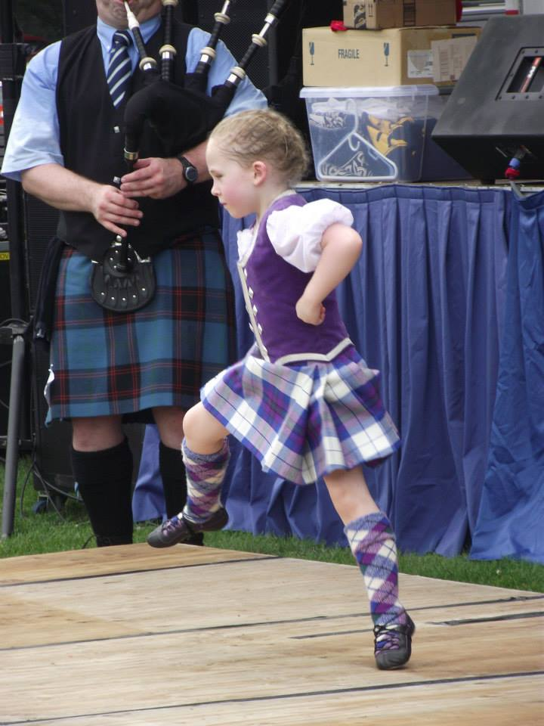

Entry Form

Closing Date: July 1, 2017

Name:______________________________________

Street: ______________________________________

City: _______________ State: ____ Zip: ________

E-mail: _____________________________________

DoB: ____________ Age (on 7/15/17): _____

Class: ____________ FUSTA#: _______________

Event #s: ___________________________________

Total Enclosed in US Dollars: $_________ $___

Detach this section and mail to:

**Maggie Carchrie, BATD**

**53 Loon Place**

**South Windsor, CT 06074**

Checks payable to:

**Glasgow Lands Scottish Festival**

Please include **entry form, check,** and **Self Addressed Stamped Envelope** (SASE). Entries without SASE will not be processed. No field entries will be accepted.

I understand that the Glasgow Lands Scottish Festival has no responsibility for injury or loss incurred to the above competitor in attending or participating in the dance competition on July 15, 2017. I agree that photographs taken in connection with my participation may be used in publicity by GLSF.

Signature: __________________________________ (Parent or guardian if under 18)